Unhalt Reversion Strategy
Connor Byhre
- Introduction
A trading halt occurs when a stock moves too far, too quickly, relative to what the exchange defines as an acceptable range. Under the Limit Up Limit Down system (LULD), every stock has a reference price along with an upper band and a lower band that set the allowable range for trading. If orders attempt to execute outside this range, the stock enters a limit state, and if the imbalance persists for more than fifteen seconds, the exchange pauses trading. During the pause, the order book freezes, no trades occur, and price discovery stops. When the halt ends, the exchange publishes a reopening price and the stock reenters the market inside a thin book that must rebuild in real time. This produces a distinct regime change: the price process jumps from a state of complete inactivity to a state of sudden activity, a structure that behaves like a Markov transition between two well-defined states.
The Unaltered Reversion Strategy focuses on the immediate reaction that occurs in the first moments after the unhalt. Not every stock falls when trading resumes, but when the first movement is a downward move that does not reflect new fundamental information, the price frequently rebounds within seconds as the order book stabilizes. In a Markov framework, this corresponds to the system entering a “first-move-down” state, which then transitions into a short-horizon reversion state with a measurable conditional probability. Empirically, after five seconds, the probability that the price is above the first unhalt price is 65.73%, meaning that once the process enters the first-move-down state, it transitions into a recovery state more than half the time. This repeated state-dependent behavior suggests that the structure of the LULD mechanism itself creates conditions that generate a reliable short-term inefficiency. The purpose of this paper is to examine that reaction and evaluate whether it represents a consistent and statistically significant market inefficiency.

- Data Pipeline and Screening Architecture
This strategy relies on a fully automated data pipeline designed to identify, validate, and track intraday trading halts in real time while minimizing contamination from fundamentally driven repricing events. The objective of the pipeline is to construct a clean sample of volatility driven halts and precisely measure price behavior in the seconds immediately following unhalting.
The pipeline operates on a rolling intraday basis and integrates three primary data sources. First, a continuously updated halt log is maintained using exchange reported halt timestamps stored in a structured CSV database. Second, real time price data is sourced from Webull, which provides second by second last trade prices for actively traded equities. Third, a live news feed is scraped from StockTitan and used to identify and exclude halts associated with material information releases.
To ensure that only active and relevant halts are analyzed, the pipeline applies a rolling time window filter. At each iteration, only halts that occurred within the prior 20 minutes are considered. Each halt is uniquely identified by the ticker symbol and halt timestamp, allowing the system to track repeated halts in the same security as distinct events rather than aggregating them into a single episode.
Before a halt is formally recognized, the pipeline requires confirmation of a true trading suspension. A halt is only confirmed if the observed price remains unchanged for a continuous 30 second window. This requirement filters out false positives arising from temporary illiquidity, delayed prints, or low activity microstructure effects. Once confirmed, the last observed trade price is recorded as the halt price and serves as the reference point for all subsequent analysis.
To control for the primary failure mode of the strategy, namely halts triggered by fundamental information, the pipeline incorporates a dynamic news screening mechanism. All halted tickers are continuously cross checked against a live news feed. If a ticker is associated with a material news release within the prior 60 minutes, it is immediately blacklisted and excluded from both analysis and execution. This blacklist is enforced dynamically, meaning that even if a halt initially appears volatility driven, the event is discarded if new information is detected while the stock is halted or during the early unhalt phase.
Following halt confirmation, the pipeline monitors the security for an unhalt signal. An unhalt is detected as the first observed price change following a period of price stasis. Once trading resumes, the system records the first post unhalt trade price and tracks second by second price evolution for a fixed 30 second window. This window length is chosen to capture the immediate order book reformation phase while avoiding contamination from slower intraday trends.
Finally, additional screening rules are applied to ensure consistency across events. Only halts where the first post unhalt price movement is downward are retained, aligning the empirical sample with the conditional framework analyzed later in the paper. Events that fail to exhibit a downward move within the first ten post unhalt ticks are excluded. These combined filters produce a high confidence sample of mechanically driven halts suitable for short horizon statistical analysis.
- Halt Identification
A trading halt is identified as a discrete state in which price discovery temporarily ceases and no transactions occur. In practice, this state must be inferred from observed trade data rather than relying solely on exchange labels, as delayed prints and illiquidity can mimic halt like behavior.
To robustly identify a true halt, the pipeline applies a price stasis criterion. For each candidate ticker, second by second trade prices are monitored continuously. A halt is only confirmed if the observed trade price remains exactly unchanged for a continuous 30 second interval. This requirement ensures that the security has entered a genuine suspension state rather than experiencing a transient pause in trading activity.
Once the stasis condition is satisfied, the halt is marked as confirmed and the final observed trade price is recorded as the halt price P₀​. This price serves as the reference point for all subsequent measurements, including first post unhalt displacement and recovery probabilities. The timestamp at which the 30 second stasis window completes is treated as the effective halt confirmation time.
This approach provides two key advantages. First, it eliminates false halt detections caused by sparse liquidity or delayed executions. Second, it aligns the analysis with the market microstructure reality faced by traders, where the precise moment of exchange level suspension is less important than the observable cessation of trading and order book updates.
Repeated halts in the same security are treated as independent events. Each halt is uniquely indexed by its ticker symbol and confirmation timestamp, allowing the analysis to capture cascading halts that occur during extreme imbalance episodes without aggregation bias.
By requiring explicit confirmation of price stasis, the halt identification procedure ensures that all events in the sample correspond to well defined regime transitions from active trading to complete inactivity. This clean state definition is critical for isolating the structural effects that emerge when trading resumes.

- Data Analysis
Average Cumulative Price Change
The plot below displays the average cumulative percentage change of the stocks over time after the unhalt given that the first price movement is downwards.
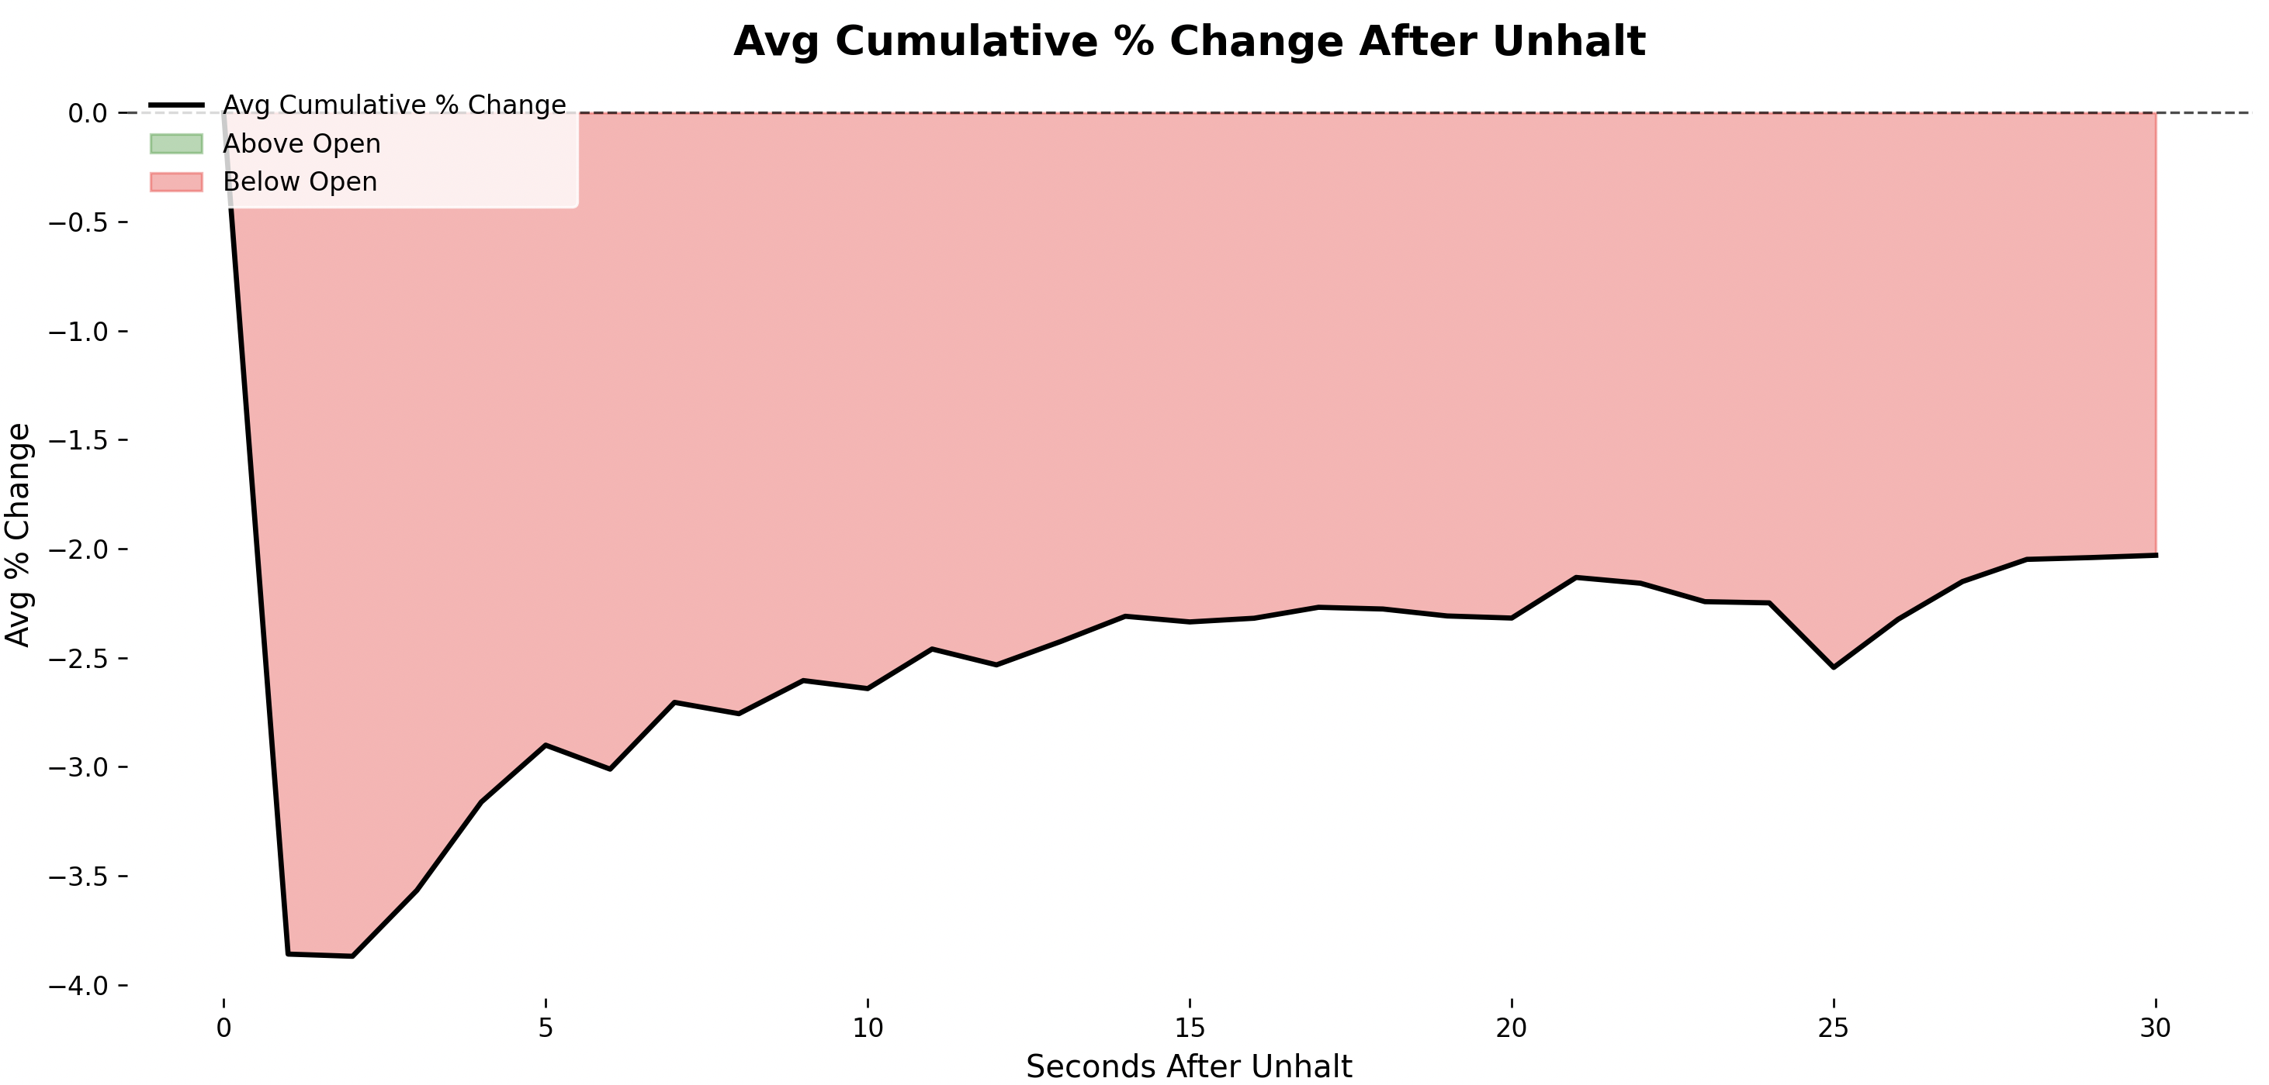
The plot shows that the empirical probability of the price being above the halt price is consistently higher than the probability generated by the Monte Carlo simulation that uses the same second-by-second volatility. While both curves rise over time, the real data recovers faster and to a greater extent than the simulated diffusion process. This indicates that volatility alone does not fully explain the observed post-unhalt behavior.
Because the simulation is calibrated directly from the real second-by-second movements and assumes no drift, any systematic difference between the two curves reflects structure in the price process rather than parameter choice. The higher empirical probabilities suggest that, conditional on the first move being downward, prices exhibit a tendency to revert above the halt price more frequently than would be expected under a purely random model. This supports the presence of a short-term, state-dependent reversion effect following trading halts.

Post-Unhalt Recovery Probability
After a trading halt, we condition on events in which the first price movement upon resumption is downward. Let P₀ denote the unhalt price and let P₁​ denote the price immediately after the first post-unhalt trade. By construction, this first move satisfies $P_{1}=P_{0}+Δ_{1}, Δ_{1}<0$
Empirically, the average magnitude of this initial displacement across the sample is approximately $Δ_{1}≈-4.13\%.$ To construct a stochastic benchmark for subsequent price evolution, we model prices after the first trade as a discrete-time random walk starting from P₁​. For t ≥ 2, the post-unhalt price process is given by:
$$P_{t}=P_{1}+\sum_{k=2}^{t}{ε_{k}}$$
where the increments {ε_{k}} are assumed to be independent and identically distributed with zero mean and constant variance, $E\left[ε_{k}\right]=0, \text{Var}\left(ε_{k}\right)=σ^{2}.$ The volatility parameter σ is calibrated from the empirical second-by-second price changes observed after unhalting, yielding an estimate of $σ≈1.63\%$
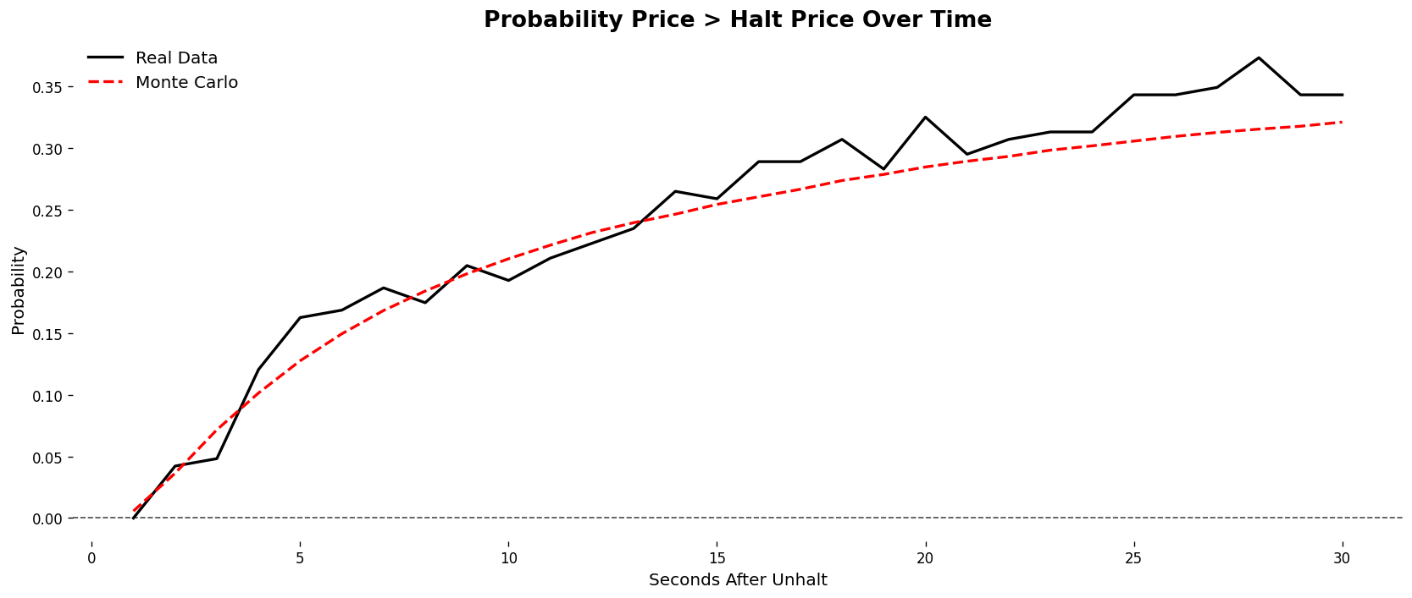
The empirical probability curve closely tracks the Monte Carlo simulation that is calibrated using the second-by-second volatility from the real data. Both curves exhibit a similar shape and evolution over time, indicating that the observed post-unhalt probabilities are largely consistent with what would be expected from a diffusion process with comparable volatility. This suggests that the overall recovery behavior can be reasonably explained by the magnitude of short-term price fluctuations observed in the data.
Post-Unhalt Recovery Probability Relative to the First Unhalt Price
Under a standard diffusion framework, post-unhalt prices are commonly modeled as a stochastic process with no directional bias. In particular, if prices evolve according to a zero-drift Brownian motion$, dP_{t}=σ dW_{t},$ then the process has symmetric, independent increments and is a martingale with respect to its natural filtration {F_{t}}. As a result, for any t > s, the conditional expectation of future price changes satisfies:
$$E\left[P_{t}-P_{s} ∣ F_{s}\right]=0$$
However, rather than measuring recovery relative to the halt price, we instead examine the probability that the price exceeds the first unhalt price. Conditioning on the first post-unhalt price movement being downward, we study the time evolution of
$$P\left(P_{t}>P_{1} ∣ Δ_{1}<0\right)$$
Under the zero-drift diffusion model, symmetry of the increments implies that for all t > 1, $P\left(P_{t}>P_{1}\right)=\frac{1}{2}.$ Which provides a natural benchmark for comparison with the empirical probabilities observed in the data.

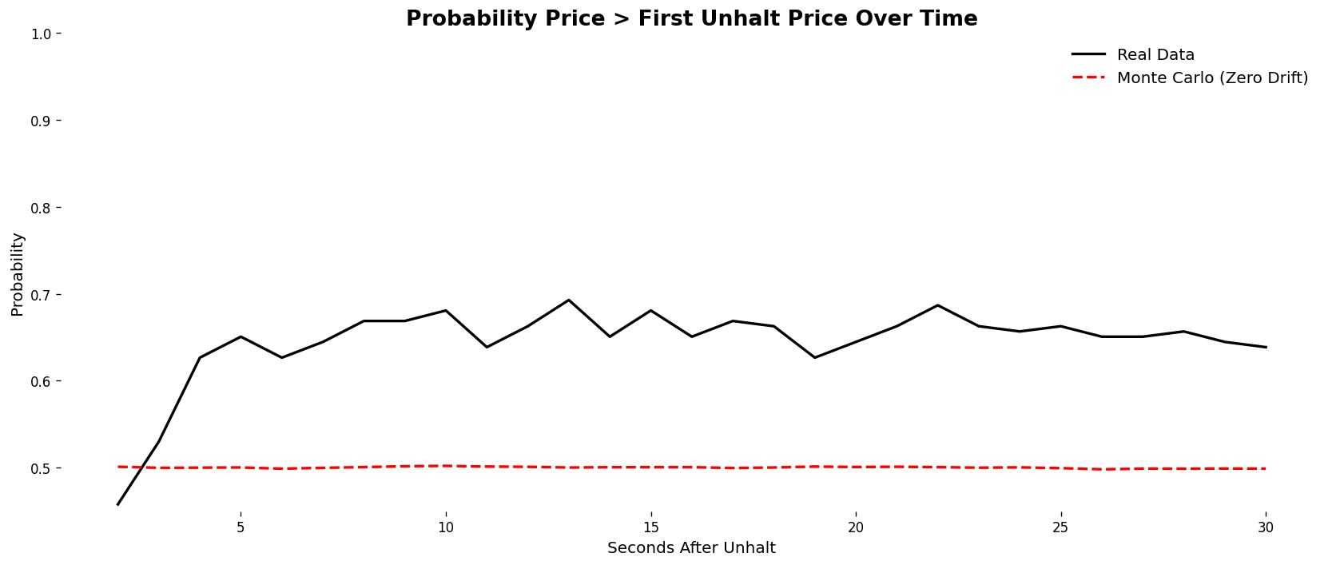

The red dashed line shows the Monte Carlo benchmark from a zero-drift, symmetric process, implying a constant 50% probability of trading above the first unhalt price. The black line shows the empirical probability conditional on an initial downward move. Unlike the benchmark, the empirical probability rises quickly above 50% and remains elevated around 63–68% over the 30-second window. This divergence indicates that post-unhalt price movements are not symmetric around the first unhalt price and exhibit a systematic upward bias following an initial decline.
- Statistical Testing
To determine whether the observed conditional probability of recovery (65.73%) is statistically significant, we perform a one-sample proportion z-test. The null hypothesis assumes that the “first-move-down” state does not create any advantage, meaning the true probability of recovering above the first unhalt price is equal to random chance, taken here as 50%.
$$H_{0}: p = 0.50$$
$$H_{1}:p>0.50$$
$$n=307$$
$$\hat{p}=0.6573$$
$$p_{0}=0.50$$
$$z=\frac{0.6573-0.50}{\sqrt{\frac{0.50\left(1-0.50\right)}{307}}}$$
$$z = 5.51$$
$$p\text{-value}<0.000001$$
Because the p-value is effectively zero, we reject the null hypothesis. With a sample size of 307, the observed recovery probability of 65.73% is highly statistically significant. This means the transition from the “first-move-down” state into a recovery state is far stronger than chance and reflects a true state-dependent market effect consistent with a Markov-style process.

- Risk
A key risk to the unhalt reversion strategy arises when trading halts are triggered by new fundamental information rather than temporary volatility or order-book imbalance. In these cases, the halt suppresses trading while market participants process the news, allowing selling pressure to accumulate. When trading resumes, this pressure is released immediately, frequently resulting in continued price declines rather than short-horizon reversion.
The APVO halt on June 18, 2025 provides a clear example of this risk. Following the announcement of an $8 million at-the-market offering, APVO quickly sold off sharply, due to the volatility the stock was halted at 9.64, once APVO unhalted the price dropped. This first move downward would trigger a buy signal, however due to the news driving the price, the stock continued to drop eventually halting at 6.24 within seconds. 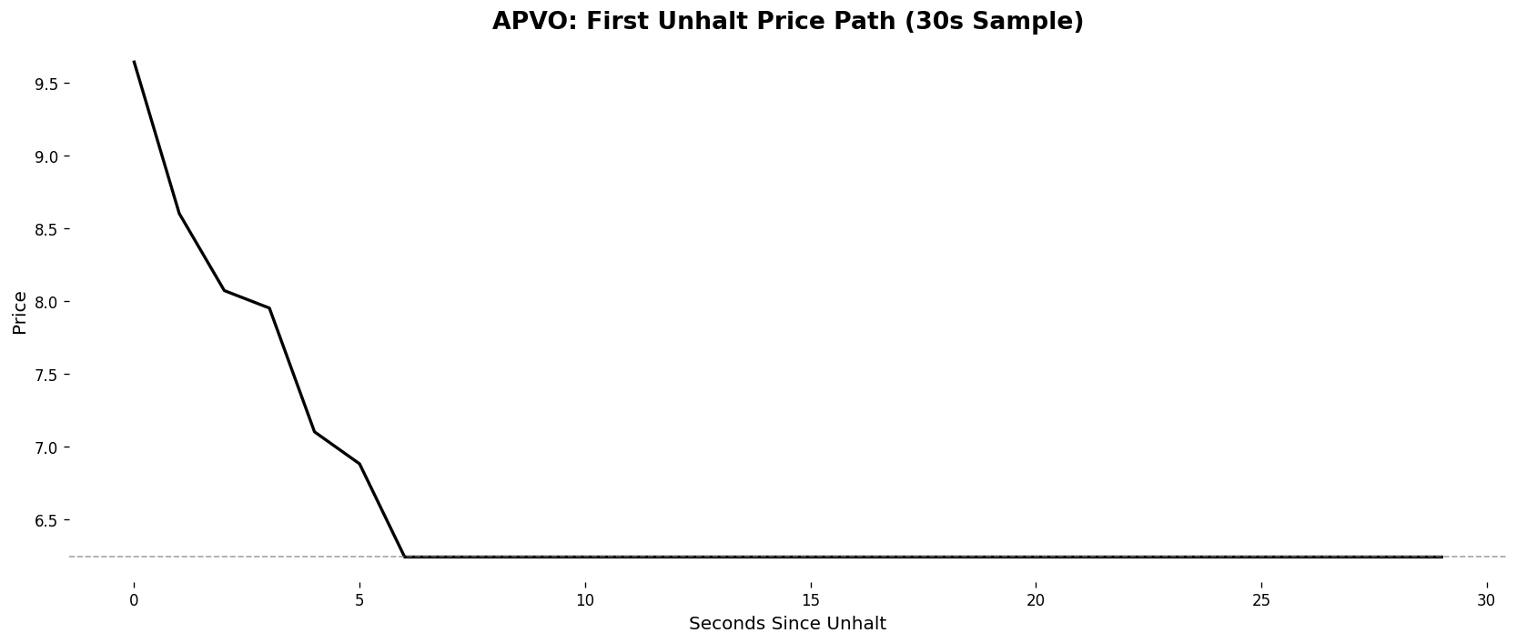
Upon the subsequent unhalt, prices again declined rapidly, falling to 4.99, where the stock halted for a third time, reflecting persistent imbalance rather than equilibrium formation.
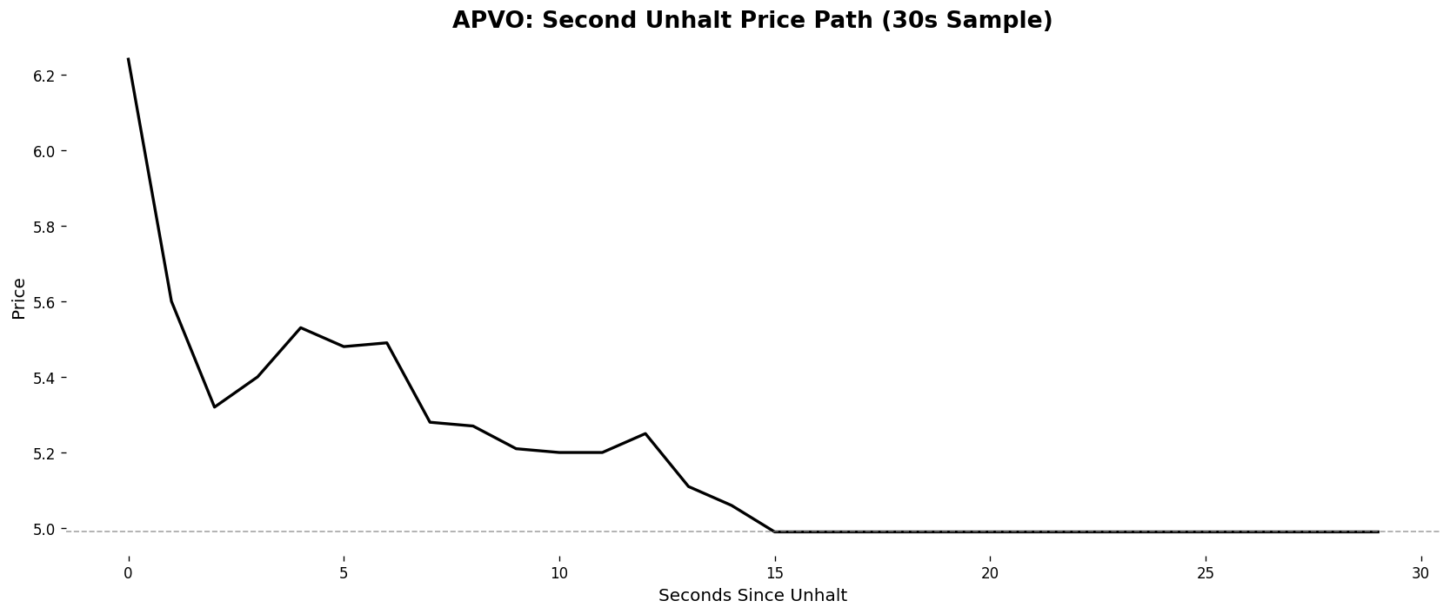
In just a matter of 21 seconds of treading the price of APVO dropped roughly 47%.
Fundamental Halt Risk & News Filtering
To account for the risk of news driven halts during live execution, the trading algorithm incorporates multiple real time safeguards designed to prevent entries during fundamentally motivated repricing events. First, halted stocks are continuously cross checked against a live news feed scraped from StockTitan. Any ticker with a material news release within the prior 60 minutes is immediately blacklisted and excluded from trading, both before and during the unhalt process. This blacklist is enforced dynamically, meaning that even if a halt initially appears volatility driven, the strategy will abort execution if new information is detected while the stock is halted or in the early unhalt phase.
Second, the algorithm requires a confirmed halt state before monitoring for an unhalt signal. A halt is only recognized if the price remains unchanged for a continuous 30 second window, reducing false positives caused by temporary illiquidity or delayed prints. Upon unhalt, the strategy does not immediately enter a position. Instead, it waits for evidence of a post unhalt downward move relative to the halt price, consistent with the empirical setup tested in the earlier analysis. If no such move occurs within the first ten post unhalt ticks, the trade is skipped entirely.
Finally, execution risk is further controlled through position sizing and time based exits. Orders are split into multiple sub orders to reduce market impact, and positions are held for a strictly limited horizon before being exited in staggered sells. These constraints ensure that exposure to adverse continuation moves, such as those observed in the APVO case where selling pressure persisted across multiple unhalts, is minimized. Together, these filters and execution rules restrict the strategy to halts that are more likely driven by mechanical order book dislocations rather than fundamental repricing.

- Execution Model
Pre-Trade Identification & Filtering
Execution is gated by two primary filters to ensure the "mechanical" nature of the trade:
- Price Stasis Confirmation: A halt is only "tradeable" after a continuous 30-second window of zero price movement.
- Dynamic News Blacklist: Real-time scraping of feeds (e.g., StockTitan) continuously checks for material announcements. If news is detected at any point—even during the unhalt monitoring phase—the ticker is immediately blacklisted.
Entry Logic (The Reversion Trigger)
The model uses a conditional entry trigger to align with the "first-move-down" state identified in your research:
- The 10-Tick Rule: The algorithm monitors the first 10 post-unhalt ticks. If the price does not trade below the halt price (P0​) within this window, the signal is considered void and the trade is skipped.
- Entry Execution: Once a downward move is confirmed, the system initiates a position using staggered sub-orders. This reduces market impact in the "thin" post-unhalt order book.
Risk & Position Management
- Fixed Dollar Sizing: To maintain statistical consistency across various stock price points, positions are sized on a fixed dollar basis rather than a share count.
- Time-Decay Exit: Following the empirical evidence that reversion is a short-lived microstructure phenomenon, positions are held for a strictly limited horizon (e.g., 30 seconds).
Exit Strategy
To capture the reversion without becoming "liquidity for the next move," the exit is managed as follows:
- Staggered Liquidation: Similar to entry, the exit uses multiple sell orders to capture the average price of the reversion peak and minimize slippage.

- Results
The algorithm demonstrated exceptional performance during the live testing period from July 16th to December 1st, 2025, generating a 27.61% total return and significantly outperforming the SPY benchmark of 7.00%. By risking 5% of capital per trade across an average of 4.7 halt opportunities per day, the strategy maintained a robust real-world win rate of 61.44%. While this realized win rate is slightly lower than the theoretical probability of 65.73%, likely due to slippage.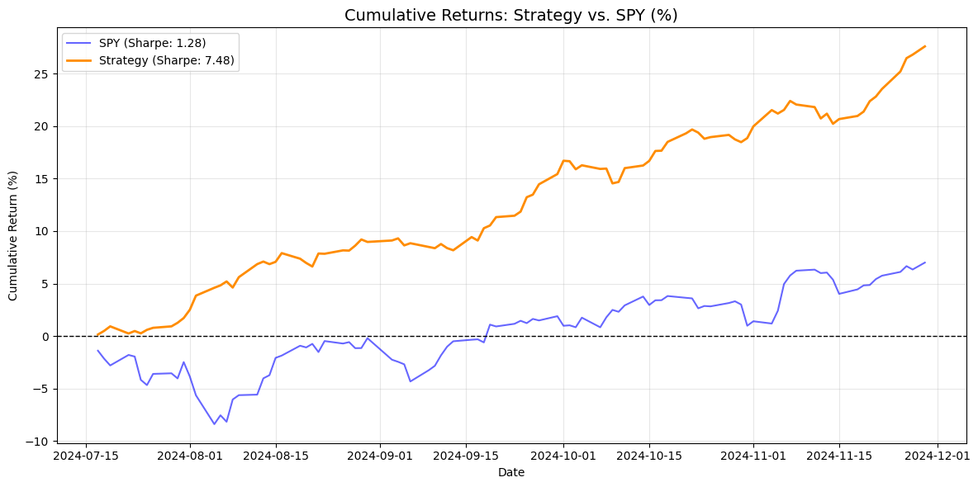
Metric | Strategy | Benchmark (SPY)
Sharpe | 7.48 | 1.28
Cumulative Return | 27.61% | 7.00%

- Conclusion
This study demonstrates that the Limit Up-Limit Down (LULD) circuit breaker mechanism introduces a quantifiable, mechanical inefficiency into the market microstructure. By isolating "clean" halts (no fundamental news) the research identifies a significant state-dependent bias: when a security unhalts and its initial price action is downward, it exhibits a 61.44% empirical win rate for a 30-second reversion. This performance remarkably outperformed the SPY benchmark (27.61% vs. 7.00%) over the five-month testing period, even when accounting for the friction of live execution. The findings suggest that the immediate post-unhalt environment is characterized by temporary liquidity vacuums and order book imbalances rather than efficient price discovery. Ultimately, while fundamental news remains a primary risk factor that can override these mechanical signals, a strictly rule-based execution model focused on liquidity-driven volatility can successfully capture alpha that is largely uncorrelated with broader market movements.

